Inclusive
Clubs Project
Expression of Interest

Help your club attract and support a more diverse membership that encourages participation and leadership from people, no matter their age, gender, sexuality, race, faith or ability to participate in sport.

The Project
Access Health and Community is seeking Expressions of Interest (EOI) from Sport and Recreation Clubs in the cities of Boroondara and Manningham to attend six free two hour workshops. The aim of these workshops is to build the knowledge of club officials on how to make their club more inclusive by creating safe, equal and respectful environments for all members, particularly women and girls.
We are working in partnership with the City of Boroondara, Manningham Council and Women’s Health East to provide these workshops. The workshops will be facilitated by Leisure Networks. Leisure Networks are industry leaders in club development. They work with all types of community sporting clubs, leagues, associations and state sporting bodies, supporting them with tailored programs and resources.
Participants will be taught practical actions that can be undertaken to promote inclusion, and highlight the benefits for clubs in creating more welcoming environments. In turn, this will help to increase female participation and retention rates for their club at all levels. The workshop topics include; governance, policy development, inclusive board structures and leadership, club culture, recruitment, advertising and equity planning.
Expressions of Interest close Sunday 17 November at midnight.

What you and your club will receive

Understand the needs of your club and its local community.
Suggest evidence-based ways to address needs identified.
Work with you to develop a tailored inclusion plan
Assist your club to implement actions.
Measure and celebrate successes
How we work with you:
In joining the project, you and your club will benefit from:
- Practical training, focussed on giving clubs practical actions to increase their inclusivity
- Peer-to-peer learnings from other club officials
- Access to high quality templates and resources
- A comprehensive inclusion assessment of your club’s culture, systems and policies
- Assistance in developing an inclusion plan
- A dedicated health promotion practitioner to help your implement actions in your inclusion plan.

What we require from you:
As a workshop participant, you will agree to be an advocate and club role model for inclusion and in particular supporting female participation at your club, both on and off the field. Participating clubs must commit:
- At least two club representatives at every workshop (with at least one being a committee member)
- Active participation at every workshop
- A commitment to complete an inclusion assessment and a tailored inclusion plan to implement actions involved over a 12-24 month period following. We will help you to develop your clubs’ inclusion plan.
Throughout the workshops, clubs will be given key information and assistance in developing inclusion plans. As a workshop attendee, you’ll then share your learnings with your committee for further discussion and implementation.

The Workshops
The six facilitated workshops will address the following topics:
- An introduction to inclusion
This session introduces participants to the project and looks at the drivers of equity and inclusion in sporting clubs. Inclusion will be covered from a number of differing perspectives and community groups.
- Governance and policy development
Promoting a welcoming attitude amongst members and develop action plans, policies and procedures to support inclusion.
- Board structure and leadership
Designed to create an enabling environment which encourages more women to serve on club committees. Supporting women in leadership roles and enhancing diversity for decision making.
- Club culture and environment
Shifting the social dynamic to be more accepting of women. Focussing at the committee level to then filter down to members and supporters.
- Recruitment and advertising
Strategies and processes to identify and support club values for recruitment of players and committee members. This will enable the committee to operate within an inclusive framework that increases access and opportunity for all.
- Women’s leadership, and governance with a focus on gender
Creating training and development pathways for members to pursue leadership roles.

Where and when?
- Workshops will commence in December 2019 and conclude in June 2020.
- Workshops will be held in a central location for participants in both cities of Boroondara and Manningham.
- Inclusion plans will be developed in July 2020
- Assistance to implement actions is available up until June 2022

Fees and Charges

There are no costs associated with participating in the Inclusive Clubs workshops. This is a partnership between AccessHC, City of Boroondara, Manningham Council and Women’s Health East. There may be costs associated with implementing actions within the inclusion plan. Assistance can be provided to assist clubs apply for grants to meet these costs.
Selection Process
- Expression of Interest can be made by completing the online form at:
www.surveymonkey.com/r/InclusiveClubs1920
- Expressions of Interest close Sunday 17 November at midnight.
- All EOI’s will be assessed by a selection panel from AccessHC, City of Boroondara, City of Manningham and Women’s Health East.
- A phone discussion may be required with representatives to clarify expectations for the project.
- EOI will be assessed according to their demonstrated commitment and alignment to the Principles within the relevant Council’s Sport and Recreation Strategy
  - The Boroondara Sport and Recreation Strategy can be downloaded from Council’s website: www.boroondara.vic.gov.au/about-council/council-administration/policies-plans-and-strategies
  - The Manningham Recreation Strategy can be downloaded from Council’s website: www.manningham.vic.gov.au/file/1551
- If you require a hard copy of the EOI, please contact health.promotion@accesshc.org.au

More Information

For more information about the inclusive clubs project
Clubs in City of Boroondara contact:
Leased Sporting Clubs
Danielle Calautti Danielle.Calautti@boroondara.vic.gov.au 03 9278 4845
Seasonal Sporting Clubs
Julia Wallace Julia.Wallace@boroondara.vic.gov.au 03 9278 4829
Clubs in Manningham Council contact:
Anissa Gracie Anissa.Gracie@manningham.vic.gov.au 03 9840 9330

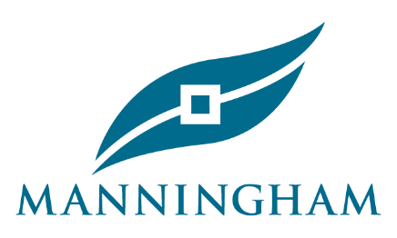
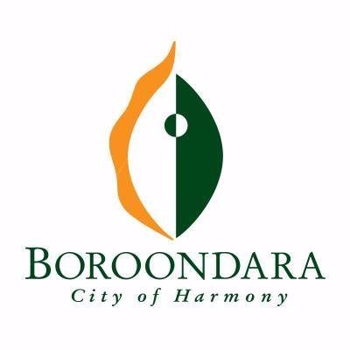
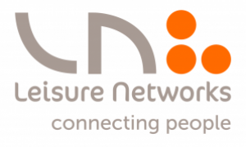
The Inclusive Clubs Project is a partnership between the following organisations:

